Minser Chiropractic Clinic Database

Minser Chiropractic Clinic,
203 Park Ave S, St. Cloud, MN 56301,
Phone: 323-253-5650
Dr. Katherine Leither, Owner
Mission Statement

“To serve patients, families and our community with compassion and concern to helping them restore and maintain an optimal state of health and well-being through chiropractic care, lifestyle modifications and wellness coaching.”

Business Goals & Values:

To the best of their ability, Minser Chiropractic promises to:
- Honor your health
- Deliver the best possible chiropractic care
- Provide care that enhances your body's own ability to heal
- Continue to improve our skills and knowledge through study and research
- Provide a welcoming and friendly atmosphere to children and families
- To care for you as we would our own families
Source: Chiropractic Team - St. Cloud, MN - Minser Chiropractic Clinic

Organization Chart:

General Systems Diagram

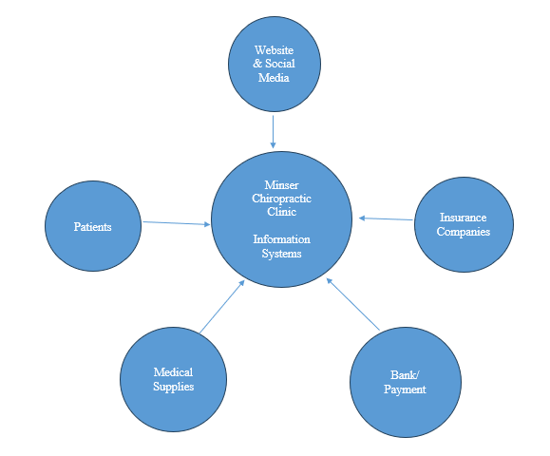

Known Problems
- The current system is not fully integrated, causing disconnection between different functions.
- Patient records, appointment scheduling, billing, and reporting are managed separately.
- This separation leads to duplicate data entry, increasing the risk of errors and inconsistencies.
- Appointment scheduling often results in conflicts, overlaps, and inefficiencies due to lack of coordination.
- Billing and insurance processing are performed manually, making the process time-consuming and error-prone.
- Manual processes contribute to delayed payments and inefficiencies in the revenue cycle.
- The system provides limited reporting and analytics tools, restricting effective decision-making by management.
- There are concerns related to data security, patient privacy, and regulatory compliance (e.g., HIPAA) due to the fragmented system.

Problem Summary & Importance
- Lack of centralization in the current system causes multiple operational issues:
  - Duplicate data entry across different systems increases the risk of errors
  - Scheduling conflicts occur due to lack of coordination between systems
  - Insurance processing is delayed because of manual handling
  - Reporting capabilities are limited and not easily accessible
  - Administrative workload is higher due to repetitive manual tasks
- The problem is moderate to highly visible across daily operations:
  - Staff experience inefficiencies and spend extra time on routine tasks
  - Switching between systems reduces productivity and workflow efficiency
  - Management lacks proper decision-support tools and real-time insights
  - Patients may experience scheduling delays or billing-related issues
- Efficient information management is critical in healthcare environments:
  - Accurate and accessible patient information is essential for quality care
  - Integrated systems reduce administrative workload and human error
  - Streamlined processes improve coordination among staff members
  - Better access to data supports decision-making and enhances patient satisfaction
- The current system may limit growth and service quality of the clinic:
  - Outdated processes make it difficult to handle increasing patient volume
  - Inefficiencies reduce staff productivity and slow down service delivery
  - Lack of integration prevents adoption of modern healthcare technologies
  - Long-term scalability and competitiveness of the clinic are affected
Possible Solutions
The clinic can improve its operations by implementing a cloud-based integrated management system that combines patient records, scheduling, billing, and reporting into one secure platform. This would reduce errors, improve efficiency, and provide better access to real-time data. Another option is upgrading the existing software to improve integration and reporting features. A more advanced solution would be developing a customized database system tailored specifically to the clinic’s needs, although this would require more time and investment.

Anticipated Benefits
The proposed information systems for Minser Chiropractic clinic will provide operational as well as organizational benefits as it will help with improving system performance, overall efficiency and decision making. The system will combine all patient records, billing, inventory, and insurance all in one single platform.
- Improved Operational Efficiency
The system will integrate patient records, scheduling, billing, and reporting into a single platform, reducing duplicate data entry and minimizing processing errors. This supports business value by improving productivity and reducing operational costs.
- Improved Information Quality
The system will provide accurate, consistent, and timely information. Centralized data storage will reduce inconsistencies and improve data reliability for administrative staff and management.
- Better Decision Making Support
Management will have access to real-time reports and analytics, allowing better planning, monitoring, and control of clinic operations.
- Enhanced Customer (Patient) Service
The system will reduce scheduling conflicts, improve service speed, and provide more reliable record management, resulting in higher patient satisfaction.
- Improved Security and Compliance
The new system will include stronger data protection and controlled access to sensitive patient information, supporting legal and ethical requirements.
- Organizational Growth Support
The system will be scalable and flexible, allowing the clinic to expand services and support future business needs.

The project will follow structured systems development activities to ensure successfully implementation to successfully use the integrated management system at Minser Chiropractic Clinic, the project will follow structured systems development life cycle (SDLC) activities. These tasks ensure that the system meets organizational requirements and delivers business value.

Project Tasks
1. Project Initiation and Planning
The project begins by identifying the business problem, defining project objectives, and establishing the project scope. A project plan will be developed that includes timelines, milestones, required resources, and budget estimates. Feasibility analysis will be conducted to evaluate:
- Technical feasibility- whether the technology and infrastructure can support the system.
- Economic feasibility -cost benefit analysis to determine financial value.
- Operational feasibility -whether the system will be accepted and used by staff.
- Schedule feasibility- whether the project can be completed within time constraints.

2. Requirements Determination
This task involves collecting detailed information about the current system and user needs. The goal is to understand how the clinic operates and identify system requirements such as:

- Conducting interviews with administrative staff and management.
- Observing current scheduling, billing, and record processes
- Reviewing existing documents and forms
- Identifying problems in the current system
- Defining functional and nonfunctional requirements
- Identifying user expectations and system constraints
3. Requirements Structuring and Analysis
After gathering requirements, the information will be analyzed and organized to better understand system processes and data needs by:
- Identifying system inputs, outputs, and data flows
- Defining system processes and workflows
- Modeling system requirements using diagrams (such as process or data models)
- Prioritizing system features based on importance and impact
- Evaluating alternative solutions and system improvements
4. System Design
The system design stage defines how the new system will operate and meet requirements. It would include tasks such as:
- Designing database structures for storing patient and billing information
- Designing user interfaces for staff interaction with the system
- Defining system architecture and software components
- Establishing security controls and access permissions
- Designing system procedures and workflows
- Preparing technical specifications for implementation
5. System Selection or Development

Based on system requirements and feasibility analysis, mentioned previously, the organization will select the best solution by:
- Evaluating available software vendors or cloud based systems
- Comparing alternative solutions based on cost, functionality, and reliability
- Deciding whether to purchase, customize, or develop the system
- Preparing contracts or development plans
- Configuring the selected system to meet clinic needs and size
6. System Implementation
The implementation stage involves installing and preparing the system for use after we’ve already completed the previous stages. This would possibly look like:
- Installing hardware and software components
- Migrating existing patient and operational data
- Integrating system programs (records, scheduling, billing, reporting
- Conducting system testing to verify functionality and performance
- Identifying and correcting errors or system issues
7. Testing and quality assurance
The system will be tested to ensure it meets requirements and performs reliably by:
- Unit testing of individual components
- System testing of integrated functions
- User acceptance testing to verify usability
- Security testing to protect sensitive data
- Performance testing to ensure efficiency
8. Training and documentation
Training will be provided to ensure users understand how to operate the system effectively.
- Conducting training sessions for staff
- Preparing user manuals and technical documentation
- Providing technical support resources
- Ensuring staff readiness and system acceptance
9. Managing and maintenance
After successfully testing and training, the system will fully be in place and require:
- Launching the system for daily operations
Monitoring system performance
- Providing ongoing maintenance and updates
Fixing system issues and improving functionality
- Evaluating system effectiveness and future improvements

Request for system services
Business Objectives
- Help patients manage pain and prevent disease
- Improve efficiency and quality of chiropractic care
Information & Data Needs
- Doctors: medical records, health history, pain scale, contact information
- Front Desk: insurance and appointment information
- Chiropractic Assistants: treatment records and equipment use
- Patient data stored in ChiroTouch system
- Paper forms scanned into system and then destroyed
Business Rules & Policies
- Must follow HIPAA privacy regulations
- Secure handling of patient information required
Key Stakeholders
- Owner: Dr. Katherine Leither
- Doctors and administrative staff
- Chiropractic Assistants and specialists
Organizational Values
- Focus on patient health and wellness
- Compassionate care and community service
- Support long-term health improvement
System Need
- Opportunity to improve efficiency and data management
- Integrated system to support clinic operations

Statement of Work
Project Purpose
- Analyze and improve the information system at Minser Chiropractic Clinic
- Develop an integrated system for patient records, scheduling, billing, and reporting
Project Scope
- Study the current clinic information system
- Identify system problems and requirements
- Design an improved integrated system
- Evaluate possible system solutions
- Recommend the best solution
Project Tasks
- Preliminary investigation and feasibility study
- Requirements analysis
- System design planning
- Solution selection
Project Deliverables
- Request for System Services (RSS)
- Problem Statement Summary
- System Diagrams
- Statement of Work
- Feasibility Analysis
Expected Results
- Improved efficiency
- Better data management
- Improved patient service
- Stronger decision support
Data Flow Diagram
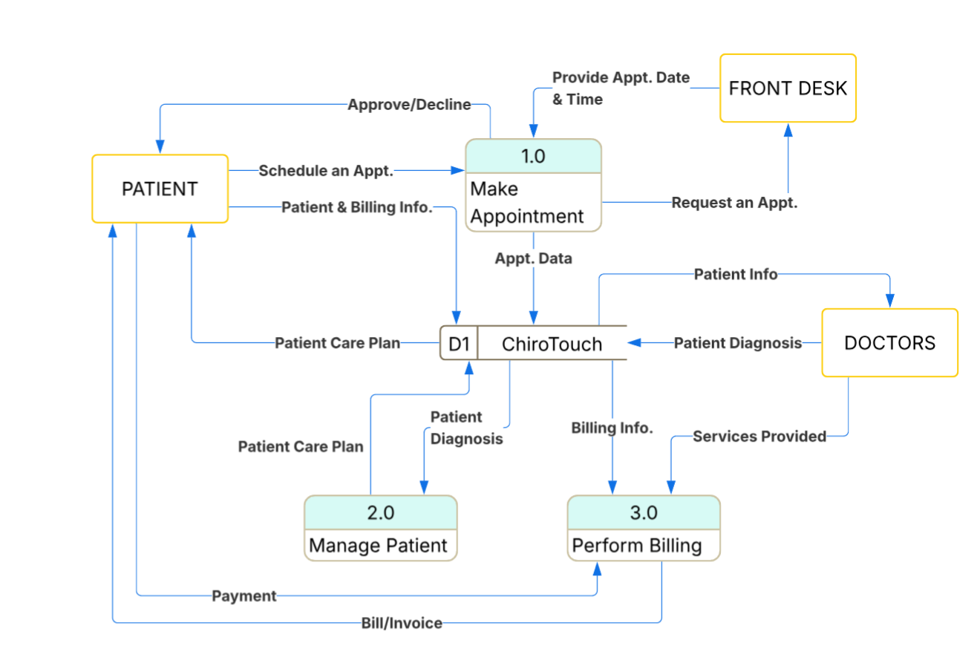

Entity Relationships Diagram (ERD)
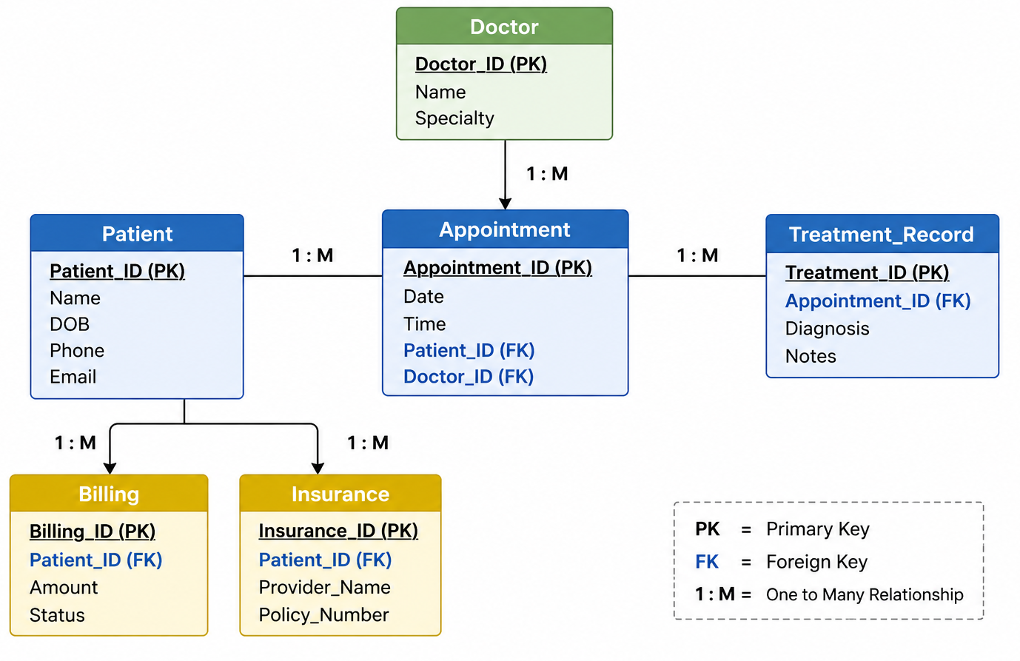
Feasibility Analysis
Operational Feasibility
- Current workflow relies heavily on manual processes and disconnected systems
- Staff would benefit from a unified platform for scheduling, billing, and patient records
- New system supports faster check-ins, reduced paperwork, and smoother patient flow
- Improves accuracy of patient information and reduces administrative errors
- Enhances patient experience through quicker service and better communication
Economic Feasibility
- Upfront costs include software licensing, implementation, and staff training
- Long-term savings from reduced paperwork, fewer billing errors, and improved efficiency
- Increased revenue potential through better scheduling utilization and reduced no-shows
- ROI expected through improved patient throughput and streamlined operations
- Budget impact manageable for a small healthcare practice

Database Design (Access Database)
Tables
- Patient
- Doctor
- Appointment
- Treatment Record
- Billing
- Insurance
Key Fields
Example:
- Patient → Patient_ID, Name, DOB
- Appointment → Date, Time, Patient_ID, Doctor_ID
- Billing → Billing_ID, Amount, Status
Database Features
- Relational structure (linked tables)
- Reduces redundancy
- Improves data accuracy
- Enables real-time access
Relationship between tables
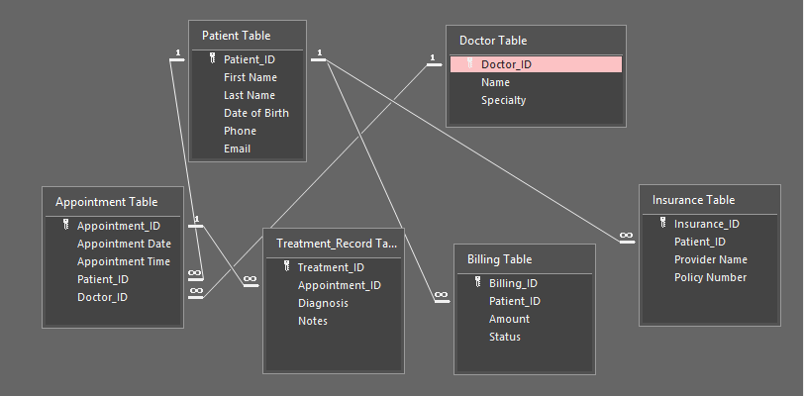

Patients Table
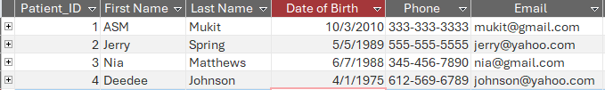
Doctors Table
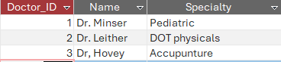
Appointment Table
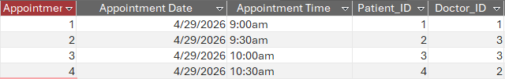
Treatment Table
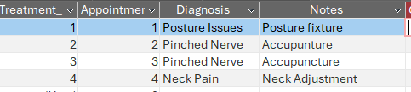
Billing Table
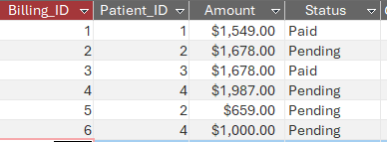
Insurance Table
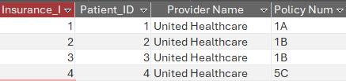
Query
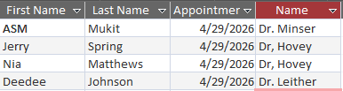
Construction & Implementation
- Database built in Microsoft Access using 6 relational tables: Patient, Doctor, Appointment, Treatment Record, Billing, and Insurance
- Tables are linked through primary and foreign keys (e.g., Patient_ID, Doctor_ID) to eliminate redundant data
- System integrates patient records, scheduling, billing, and reporting into a single unified platform
- Existing patient data from ChiroTouch and paper records migrated into the new database
- Hardware and software components installed and configured to meet clinic needs
- System tested through unit testing, integration testing, and user acceptance testing to verify functionality
Maintenance & Support
- System is monitored continuously to ensure performance, uptime, and data accuracy
- Regular updates and patches applied to keep the system secure and compliant with HIPAA regulations
- Ongoing staff training provided as features are updated or new staff are onboarded
- Technical support resources available including user manuals and documentation
- System issues identified and resolved promptly to minimize disruption to daily operations
- Periodic evaluations conducted to assess effectiveness and identify future improvements

